How To - Revit View Apps

|  |  |  |
| --- | --- | --- |
| Release Date | Version | Comments |
| 18/01/2013 | 0.1 | Draft |
| 17/06/2013 | 0.2 | Icon Update |

# Summary – View Tab

The Revit View Apps are a collection of add-ins meant to improve view creation in a Revit project. The collection is comprised of:

|  |  |  |
| --- | --- | --- |
| App Name | Icon | App Usage |
| * Create Dependant Views | Icon-Reload Family.png | Creates any number of dependant views by level |
| * Place Views on Sheets | Icon-Place Views.png | Places views on sheets based on a template sheet |
| * Create View types | Icon-Create View Types.png | Creates custom Floor, Area, Ceiling plan types |
| * Export Schedules | Icon-Export Schedules.png | Exports any number of Revit schedules as .txt files |

Within the Revit user interface the View apps can be found under the BVN Tools tab:

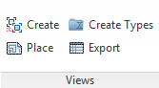

# Create Dependant Views - PReface

The ‘Create Dependant Views” app is meant to be used in project environments where the floor plate of the development does not fit on a single sheet and therefore multiple dependant views per level and package are required to document the project

# Create Dependant Views - User Interface

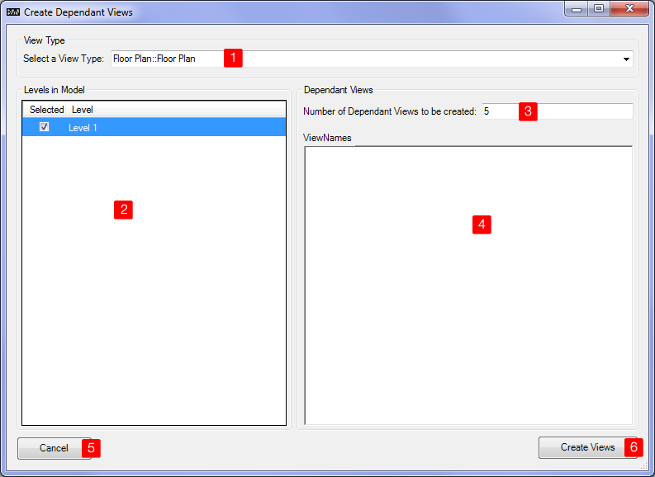

|  |  |
| --- | --- |
| 1 – View Type | The type of view to be used when creating dependant views. |
| 2 – Levels in model | This window lists all the Levels in a Revit model. One has to tick (select) levels of which dependant views are to be created. |
| 3 – Number of Dependant Views | Set the number of dependant views to be created by level. The number displayed depends on the level highlighted in blue in 2).  If the number is set to 0 only a standard view with no dependant views will be created. |
| 4 View Names | This field is optional. When left blank the created dependant views will be named 1,2,3 etc  If the names of the views to be created are already known they can be entered one name per row.  If the number of dependant views is set to 0 in 3) the first name will be applied to the parent view |
| 5 - Cancel | Cancels any user input and returns to Revit |
| 6 – Reload (x) | Will start the process of reloading all highlighted families. The number of families to be reloaded is shown in brackets. After completion a ‘Finished’ Message will be displayed. |

# Place Views on Sheets - PReface

The ‘Place Views on Sheets” app is meant to be used in project environments where a large amount of sheets with the same view setup are required.

An example would be projects with a large number of drawings in varying packages which need placing on sheets. This usually is quite a time consuming task.

# Place Views on Sheets - User Interface

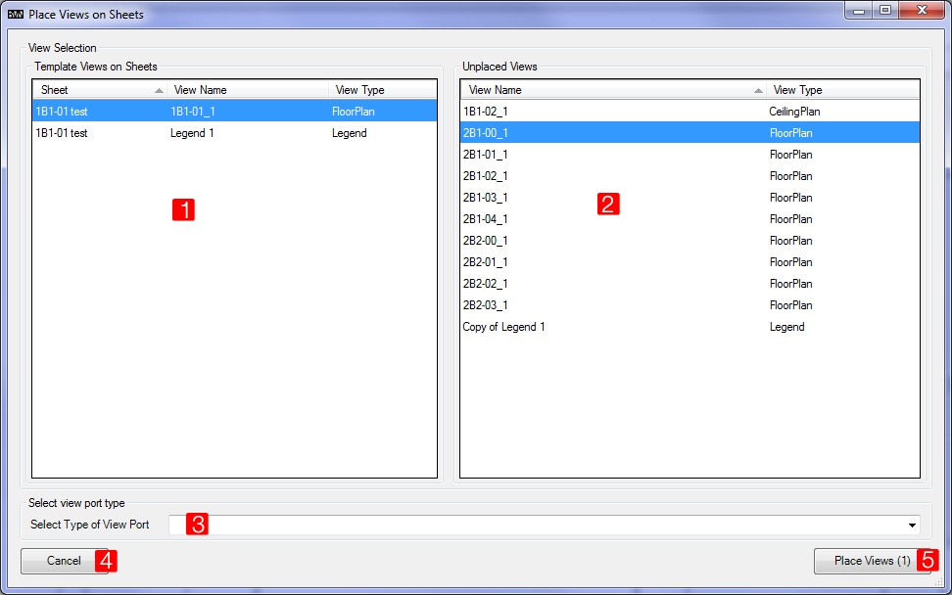

|  |  |
| --- | --- |
| 1 – Template View | Select a view which location on a sheet is used to place other views. |
| 2 – Unplaced Views / Sheets | Lists all unplaced views in the model when a plan view was selected in 1). Select all views you want to place on a sheet in exactly the same location then your template view selected in 1)  If a legend view was selected in 1) it will display all sheets in the model the **same** legend could be placed on. |
| 3 View port type | Select the type of viewport to be used for all views to be placed |
| 4 - Cancel | Cancels any user input and returns to Revit |
| 5 – Place Views (x) | Will start the process of placing views on sheets. |

# Create View Types - PReface

The ‘Create View Types app’ is meant to be used in Campus stile projects environments where the requirement arises to add view types in multiple project files to the ones provided by the template.

# Place Views on Sheets - UsAGE

The ‘Create View Type’ app requires a text file to create the view types. The file is formatted by row like shown below:

|  |  |  |
| --- | --- | --- |
| View Type Name | <tab> | View Type |
| For example: |  |  |
| BVN A1-PLANNING AND DESIGN |  | FloorPlan |

**View Type Name**: is the name of the new view type to be created. It can have spaces in it.

**View Type** can be the following:

|  |  |
| --- | --- |
| View type | Description |
| FloorPlan | Revit Floor Plan |
| CeilingPlan | Ceiling Plan |
| Drafting | Drafting view |
| ThreeDimensional | 3D view |
| Legend | Legend View |
| Walkthrough | Walkthrough |
| Schedule | Schedule |
| AreaPlan | Area plan (this appears to work only if there are area plans in the model) |

# Export Schedules - PReface

The ‘Export Schedules’ app is meant to be used when multiple Revit schedules need to be exported at the same time/

# Export Schedules - User Interface

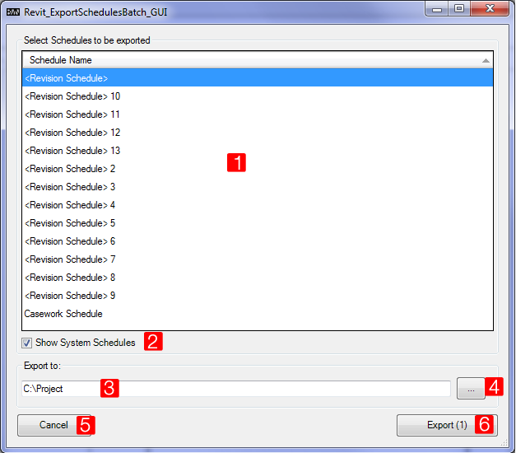

|  |  |
| --- | --- |
| 1 – Schedules | Displays all schedules in the model. Schedules in ‘<>’ are System schedules. Highlight all schedules you want to export |
| 2 – Show System Schedules | Hides or shows system schedules. I might remove that feature since system schedules (in picture revision schedules) appear to be empty / not accessible. |
| 3 - Folder Path | Select the folder where the schedules will be exported to. |
| 4- Folder browse | A folder browse dialogue will be displayed. |
| 5 - Cancel | Cancels any user input and returns to Revit |
| 6 – Export Schedules (x) | Will start the process of exporting the highlighted schedules. |